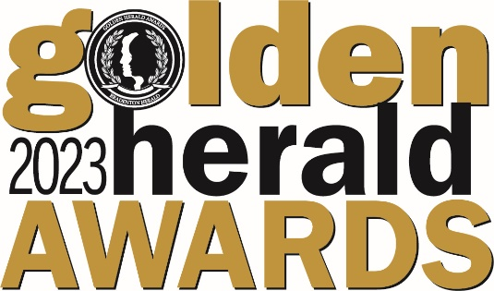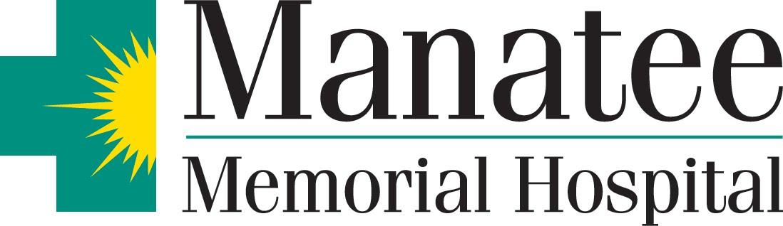

Completed Applications due by Friday, February 24, 2023 at 4:30 p.m.
Please deliver to Manatee Memorial Hospital Executive Office
Attn: Cindy Hardin, 206 2nd Street East, Bradenton, FL 34208
Student Interviews at Manatee Memorial Hospital on
Saturday, March 25, 2023 from 9 a.m. – 1 p.m.
Golden Herald Awards Ceremony at SCF Neel Performing Arts Center on Thursday, April 13th, 2023 at 6 p.m.

APPLICATION FORM:

Student Name: Category:
For judges use only

Total Eval

Mailing Address:

City: Zip:

Birth Date: / / Phone # ( )

School:

PURPOSE AND QUALIFICATIONS
The purpose of the Golden Herald Award is to recognize the outstanding Manatee County High School Seniors for unselfish SERVICE to their school and community. A Golden Herald Award is given in each category to the individual whose record of service best exemplifies the use of his or her abilities to help others. Nominees must have the equivalent of an overall B average.

Note to Nominees:
- Before completing this form, familiarize yourself with the informational brochure.
- All questions must be answered in the space provided; no supplemental data sheets allowed.
- The entry form must be typed.
- General Scholarship Category nominees must attach a complete high school transcript.
- Be sure your name is on every page.
- All type MUST be in TIMES NEW ROMAN font and at 11 pt.
- Completed entry forms must be signed by your school principal/school administrator and given to your school coordinator.

Student Name:

Judges Comments

1. How have you used your talent or skill for the betterment of school and/or community?
(Be sure to list those accomplishments directly related to your category first.)

Student Name:

2. What honors, awards or recognition have you received?

Judges Comments

(Be sure to list those achievements specifically related to your category first.)

Student Name:

Judges Comments

3. Describe what you consider the most important project or activity benefiting your school or community in
which you played a major role. Define the role you played in the project or activity.

Student Name:

4. Describe how you have adapted to learning and or community service efforts with Covid 19 restrictions in place?

I agree to appear for a personal interview at the Manatee Memorial Hospital on
Saturday, March 25, 2023 with the Golden Herald Awards judges to discuss my qualifications in my category.
I also agree to appear at the Awards Ceremony on Thursday, April 13, 2023.

I certify that all the above statements are true and correct.

______________________________________________________
Signature of Nominee

NOTE: FOR GENERAL SCHOLARSHIP NOMINEE ONLY…Please attach a complete transcript of high school grades and a report of Standardized Test Data.

Student Name:

Judges Comments

REPORT OF THE TEACHER AND SCHOOL ADMINISTRATOR

4. In what specific ways do you feel this candidate has made an outstanding
contribution in this category?
(Please limit your comments to the space provided)

Faculty Member signature:

Position or Title: Date:

I certify that all statements made by this candidate and by the above faculty member regarding grades,
rankings, offices, awards and all other school-connected activities are correct. I further certify that all other
statements made by or about this candidate in this application are true to the best of my knowledge and
belief. I recommend this candidate as a worthy representative of our high school.

Administrator’s Signature:

School: Date:

NOTE: FOR GENERAL SCHOLARSHIP NOMINEES ONLY…
Please attach a complete transcript of high school grades and a report of Standardized Test Data.

Manatee Memorial Hospital

Promotional Consent for Use of Individual’s Image, Voice, and/or Statement

Important note: This form secures your consent and authorization to use your image, voice, and/or statements in a promotional context – please review it carefully.

I hereby consent to and authorize Manatee Memorial Hospital, UHS of Delaware, Inc., and all of their affiliates (collectively “UHS”) to use my image, voice, and/or statements in commercial promotions, advertisements, social media, educational pieces, or in any other manner at UHS’ sole discretion. I understand that my image, voice, and/or statements may be recorded in videotapes, audiotapes, photographs, or interviews, and my consent and authorization applies to any such recording and may be used in whole or in part by UHS at its discretion.

I understand and agree that I have no rights to the images or materials generated by UHS in reliance on my consent and authorization, and I waive any rights I may have to prior approval of the use of my image, voice, and/or statements by UHS. I hereby release UHS and all of its respective employees, officers, directors, and agents from liability of any kind based on the use of my image, voice, and/or statement. I further waive any rights to any form of payment or compensation I may have in connection with UHS’ use of my image, voice, and/or statements.

I understand that I may revoke my promotional consent and authorization at any time by informing UHS of Delaware, Inc., attention Marketing Department, in writing that I am revoking my consent and authorization. I understand that my revocation does not apply to the extent UHS has already used my recording in reliance on this authorization or if immediate revocation would cause additional expense or hardship to UHS in completing its current promotional campaigns.

I have had the opportunity to read and consider the contents of this consent and authorization. My signature below indicates that I understand and agree to the terms herein.

Print Individual’s Name Date

Signature (Parent or Legal Guardian must sign if individual is a minor)

